Quantitative Calculation Program of Wet Steam Loss

This program is based on the results of three-dimensional non-equilibrium condensation flow of multistage turbine, and necessary treatment is carried out for the results. The program language FORTRAN 77 is used to run on Compaq Visual Fortran version 6.6 platform, and the quantitative calculation of wet steam loss is carried out.

1、Input statement description

The main input data of the program include the flow field parameters and the geometric parameters of the blade profile. The flow field parameters include the axial, radial and circumferential velocity, static pressure, supercooling, saturation temperature and turbulent kinetic energy, the density and dynamic viscosity of the vapor phase, the density, diameter, volume integral number, sound velocity and surface tension of the primary water droplet of the liquid phase, and the geometric parameters include the blade profile data of the stationary and moving blades.

**A. Treatment of flow field parameters**

The non-equilibrium condensation results of two-stage wet steam turbine are taken as an example to illustrate

1. Open the calculation result file in CFX software, as shown in the figure:

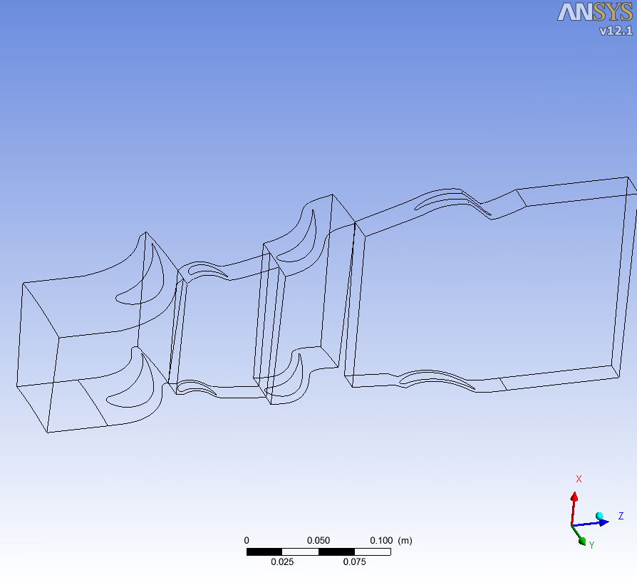

2.Initialize the flow field with turbo mode, that is, calculate the parameters of the circumferential average and calculate the velocity component.

3. Select the meridian view, in details of meridian plot, stream sample is the value of NStream in the program, span samples is the value of NSpan in the program, both of which are 11 by default in the program, or you can select an appropriate value to fill in, in plot Select contour in type, select local in range drop-down menu, select pressure in variable, fill in 30 in of contour, and finally select apply.

4. Right click in "Meridian" and select the last item "promote to general mode".

5. Choose export from the file menu bar.

6. Fill in the name of variable output "static" in the "file" dialog box Pressure.csv ”, select the corresponding surface meridian surface copy in process 5 in locations, and check the selection boxes in export geometry information, line and face connectivity and nodes numbers. At last, I get "static" under the directory Pressure.csv ” Documents.

7. “Static Pressure.csv ”The file can be opened with Notepad, and the contents are as follows:

[Name]

Meridional Surface Copy

[Data]

Node Number, X [ m ], Y [ m ], Z [ m ], Pressure ACA on Meridional Surface Copy [ Pa ]

0, 3.83682668e-001, -6.65517226e-002, 5.69999889e-002, 2.31080016e+005

1, 3.92483175e-001, -6.80782124e-002, 5.69999926e-002, 2.34018813e+005

2, 4.01283681e-001, -6.96047023e-002, 5.69999963e-002, 2.40620344e+005

......

481, 4.67789203e-001, -8.11404213e-002, 1.87979117e-001, 1.64739250e+005

482, 4.79560047e-001, -8.31821412e-002, 1.87979117e-001, 1.67147078e+005

483, 4.91330832e-001, -8.52238536e-002, 1.87979117e-001, 1.68434891e+005

[Faces]

0, 1, 12, 11

1, 2, 13, 12

2, 3, 14, 13

......

469, 470, 481, 480

470, 471, 482, 481

471, 472, 483, 482

The first line is blank, 0, 1, 2 481482483 is the output grid node, the data in the last three columns are x [m], y [m], Z [m] coordinates, and the data in the last column is the variable value on the grid node. The output above is "static pressure", i.e. static pressure. The combination of the four numbers below [faces] is the order of arrangement among the grid nodes.

8. Repeat the above step 3-7 to obtain the following 14 documents:

*Dynamic Viscosity.csv; Liquid Density.csv; Particle Diameter.csv; Saturation Temperature.csv; Sound Speed.csv; Static Pressure.csv; Super Cooling.csv; Surface Tension.csv; Turbulence Kinetic Energy.csv; Vapor Density.csv; Velocity Axial.csv; Velocity Circumferential.csv; Velocity Radial.csv; Volume Fraction.csv*.

**B. Processing method of geometric parameters of blade**

Refer to "NUMECA software" software blade geometry data version 3.7, the suffix of the blade file is "geomturbo", as shown in the figure below:

GEOMETRY TURBO VERSION 3.7

geometric_tolerance 1e-006

blade_expansion_factor_hub 0.08

blade_expansion_factor_shroud 0.05

blade_merging 0

units 1

number_of_blades 40

hub

EXTERNAL

hub.dat

shroud

EXTERNAL

shroud.dat

suction

SECTIONAL

2

#suction

XYZ

471

390 10.0929 5.4037

390 10.3384 5.3114

……

390 -52.4068 54.8211

390 -52.4103 54.804

#suction

XYZ

471

477.5 10.0929 5.4037

477.5 10.3384 5.3114

……

477.5 -52.4068 54.8211

477.5 -52.4103 54.804

pressure

SECTIONAL

2

#pressure

XYZ

421

390 10.0929 5.4037

390 9.852 5.5074

……

390 -52.4125 54.7867

390 -52.4103 54.804

#pressure

XYZ

421

477.5 10.0929 5.4037

477.5 9.852 5.5074

……

477.5 -52.4125 54.7867

477.5 -52.4103 54.804

“number_ Of_ "40" after "blades" is the number of cascades in this column. In this example, there are 40 blades in total in the whole circle. The hub and shroud parameters are written in addition to this file. Write the pressure surface first and then the suction surface data, where "XYZ" is the X, y and Z coordinates in the rectangular coordinate system. In the program, "X" is the "circumferential coordinate", "Y" is the "radial coordinate", "Z" is the "axial coordinate", for example If the coordinate definitions of X and y are inconsistent with those in the program, you can use the subfunction "read" in the program_ profile_ Adjust at the end of "parameter".

There are the following statements in the program: parameter (MS = 100, Mn = 800), where MS is the number of characteristic sections along the blade height, the maximum is 100, which can be adjusted; Mn is the number of data points from the leading edge to the trailing edge of the pressure surface or suction surface, the maximum is 800, which can also be adjusted. In the program, the geometric data of the stationary blade is arranged in the format of "S1. Geomturbo", "S2. Geomturbo", "S3. Geomturbo", and the moving blade is arranged in the format of "D1. Geomturbo", "D2. Geomturbo", "D3. Geomturbo". The name of the geometric data can be found in the program subfunction "read"_ profile_ Parameter ".

C. **For the description of the change of different turbine input data, there are the following statements in the program**

parameter (NStage=7,NSpan=11,NStream=11)

parameter (MS=100,MN=800)

parameter (zhuansu=3000*2*3.1415926/60.0)

Where nstage is the number of stages of the turbine to calculate the wet steam loss, the default is level 7, nspan is the value of "span samples" in step 3, the default is 11, nstream is the value of "stream sample" in step 3, the default is 11, MS and Mn have explained in "B" in the previous section, "xuansu" is the speed of the turbine, and the unit is rpm.

Subroutine intrinsic in programs_ power(turbine_ Power) is the output power of each stage of the turbine, which needs to be modified manually,

For different turbine stages, the program input parameters are different, mainly for nstage = 7, nspan = 11, nstream = 11, Ms = 100, Mn = 800, xuansu = 3000 * 2 * 3.1415926 / 60.0, and internal_ power(turbine_ Power) subfunction can be modified to realize general calculation.